What is Key Leader?
Key Leader is an interactive leadership education program for high school students. The Key Leader mission is to provide a life-changing experience that inspires young people to achieve their personal best through service leadership and helping others succeed.

Who can attend Key Leader?
Events are open to all students who have completed the 8th grade, including those currently in Key Club.

What happens at Key Leader?
Students arrive for registration between 4:00 and 6:00 PM on Friday and depart around noon on Sunday. To maintain the integrity of the Key Leader experience, latecomers and early departures are strongly discouraged.

The students experience large and small group curriculum, hands on activities, indoor and outdoor activities, and a ropes confidence teambuilding course.

Great food, new friends, learning about service leadership … and FUN!

WILL adults be present?
A professional Key Leader lead facilitator will lead the event. This facilitator brings to the program excellent experience working with young people and has successfully completed a training course on the curriculum.

The Kiwanis District provides trained adult volunteers to coordinate the logistics and supervise students. Kiwanis International completes a limited criminal history background check on all of the adults who will be present for the weekend.

How much does KEY LEADER cost?
The all-inclusive cost of $250 for each student includes lodging, meals and all activities.

A Kiwanis club, business, school, community organization, religious group, family or others can sponsor a student and pay the cost of registration.

Are there student leadership opportunities?
Yes. Students in 11th and 12th grades who have previously attended a Key Leader event may apply to return as a student facilitator to lead a neighborhood group.

The fee for student facilitators is $175. Student facilitators must arrive at camp by 2:00 PM to meet with the lead facilitator prior to participant arrival.



How do students register?
Registration for Key Leader begins at www.key-leader.org. All students and adult chaperones must complete a basic registration form. Please note, participants who register within 14 days of the event will be charged a $25 late fee.

Once registered, students will receive information about what to bring to camp as well as the Medical Form and Community Values form that must be signed and presented upon arrival at camp.

How CAN Kiwanis CLUBs GET INVOLVED?
When you send a teen to Key Leader weekend, you’re helping to develop a young leader.

Kiwanis clubs are encouraged to identify a student that has leadership potential but may need a small push. Support them by telling them or an educator about the camp, provide a ride to camp or sponsor their registration cost.

Clubs can also sponsor a student from another school if they are not able to identify a local student.

Kiwanis members are also needed to serve as on-site chaperones and provide snacks for the weekend.



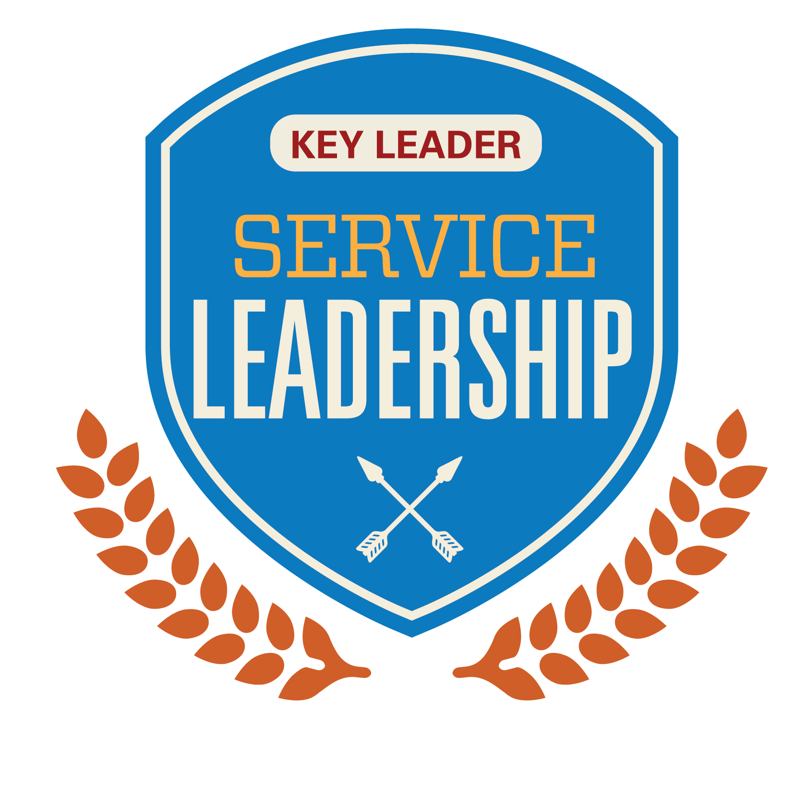

Keys to Excellence
The Key Leader program is built on five essential principles that reflect our mission to inspire young people to achieve their personal best through service leadership.

Personal Integrity
Doing the right thing.

Personal Growth
Developing in mind, body, and spirit.

Respect
Showing consideration for self, others, and property.

Building Community
Developing relationships to achieve positive goals.

Pursuit of Excellence
Expecting and achieving the best.

LEADERSHIP
It’s more than a position. It’s about the choices you make every day.

HOW CAN I GET more information?
NE-IA District Coordinator
Lynda Henningsen
402-981-4321
lhenningsen@omahadailyrecord.com

HOW CAN I SUPPORT KEY LEADER?
Send a tax-deductible donation to the Nebraska/Iowa Kiwanis Foundation
with Key Leader in the memo.

Mail checks to:
Curt Reis, Treasurer
Nebraska Iowa Kiwanis Foundation
1207 Poplar Lane
Storm Lake, IA 50588
2018 Family Reunion

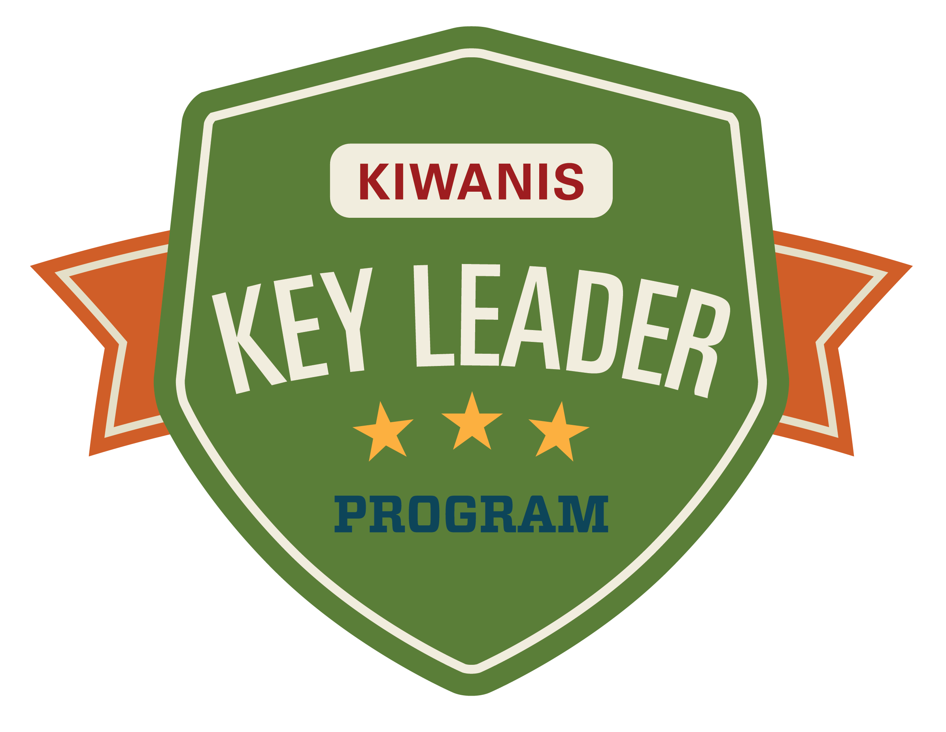

Being a Key Leader is all about
achieving excellence and becoming a
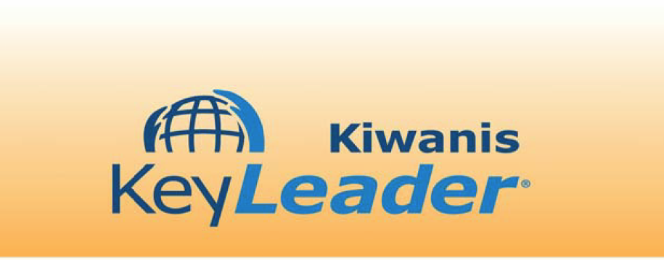
true leader—at home, at school, in the community and in the world.

November 8-10, 2019
Camp Kitaki
Louisville, NE



